ORGANIZER of the ProPark Award:  Russian Association of Amusement Parks and Attractions:  Tel.: +7 (495) 604-11-30, +7(495) 604-11-26  E-mail: raapa5@raapa.ru, Website: www.raapa.ru | 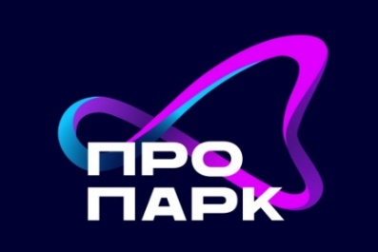
Application for participation in ProPark Award
Applications can be submitted until 12.02.2024
Registration fee | 190 Euro/200USD for participation in one nomination  95 Euro/100USD for participation in each subsequent nomination
Кандидат (укажите название компании для участия в премии)
Participation in the nomination  (mark nomination) | - «Best city park»  - «Best outdoor amusement park»  - «Best indoor entertainment complex»  - «Best water park»  - «Event of the year»  - «Expert of the year»  - «For the manufacture development in amusement industry»  - «A new project in amusement industry»  - «For contribution to the development of the entertainment industry»  «Special opinion of the jury»
Company name (legal entity for the contract)
Email
Telephone
Website
Contact person, position
Name and last name of the authorized person, position (acting on the basis of (the Charter, Regulations, Powers of Attorney)
Legal address
Postal address
TIN
Bank account
Bank name and address
Correspondent bank account
SWIFT
Status of the paticipant:
Manufacturer
Park
FEC
Other
Send the completed application by February 12, 2024 to e-mail: raapa5@raapa.ru
The application form must be accompanied by photo and/or video materials illustrating your (or your candidate’s) activities, lasting up to 10 minutes. And
essay in Word format.

